Grammatical Practice
Name ……………………………………………………………….…… Class …………. No. ……………
Unit 7 Everyone Makes Mistakes
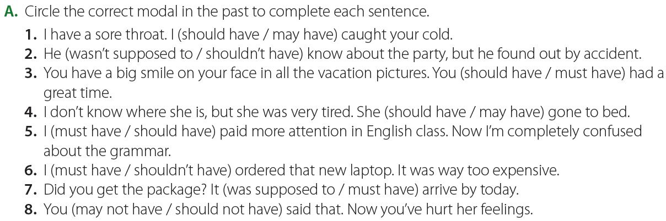
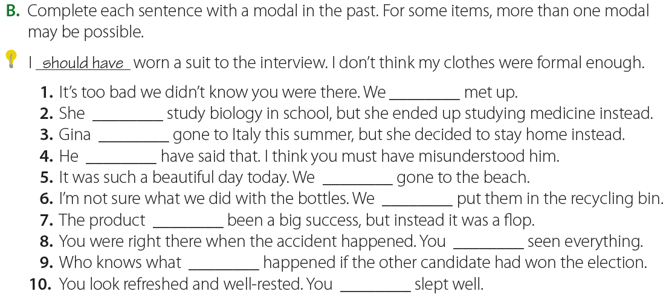
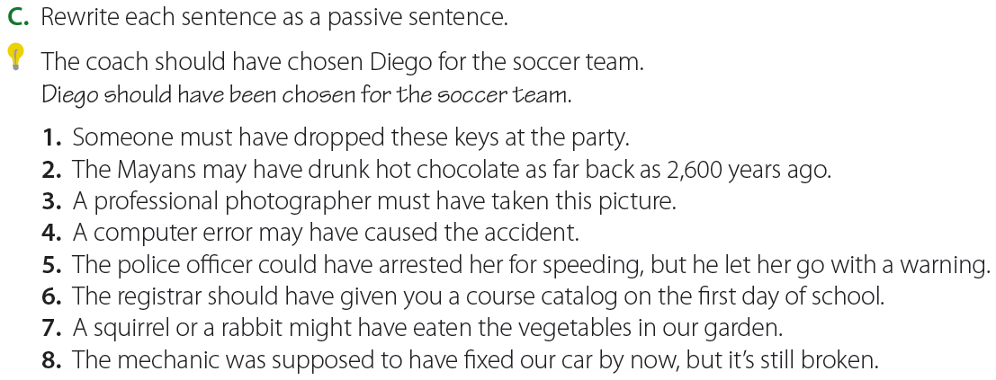

Grammatical Practice
Name ……………………………………………………………….…… Class …………. No. ……………
Unit 8 Against the Odds
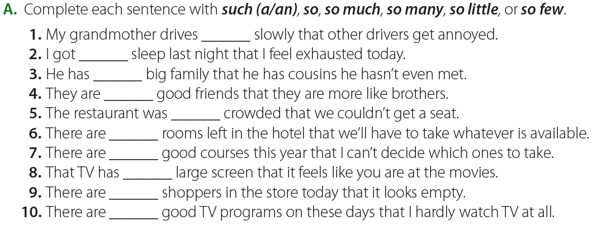
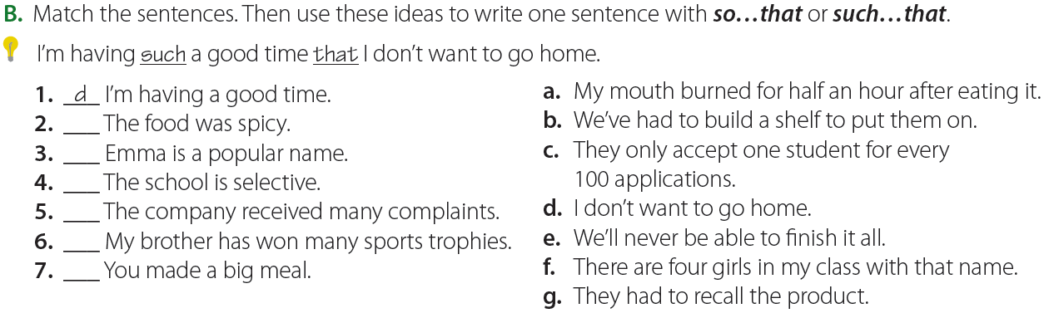
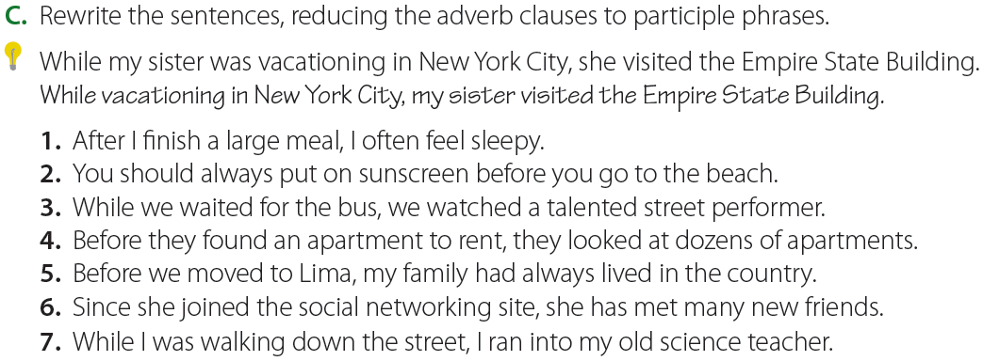

Grammatical Practice
Name ……………………………………………………………….…… Class …………. No. ……………
Unit 9 Beauty Is Only Skin Deep
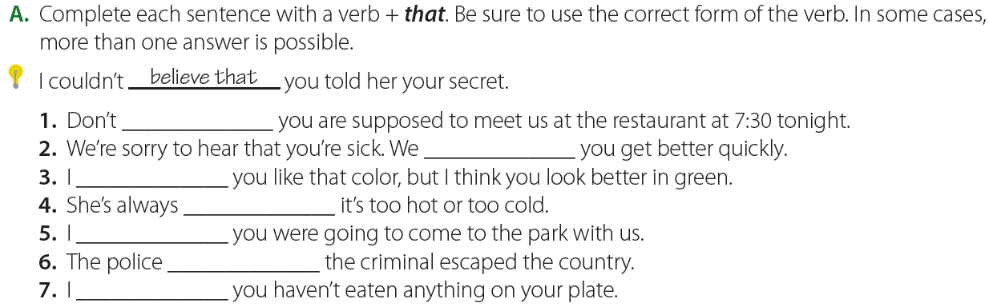
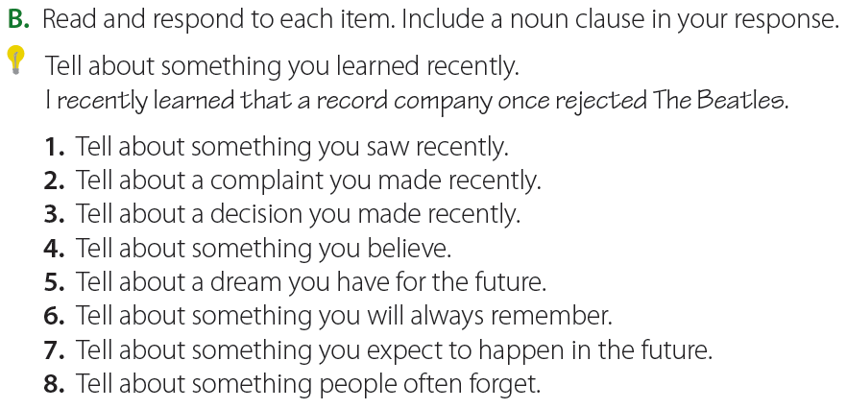
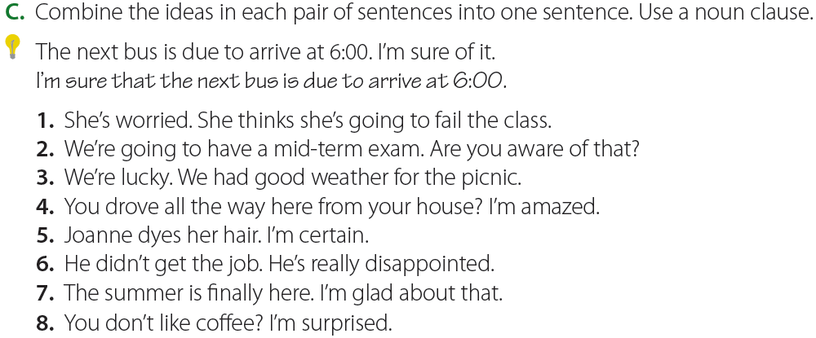

Grammatical Practice
Name ……………………………………………………………….…… Class …………. No. ……………
Unit 10 He Said, She Said
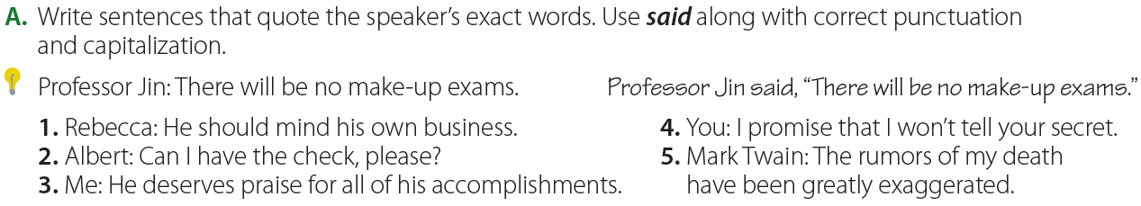
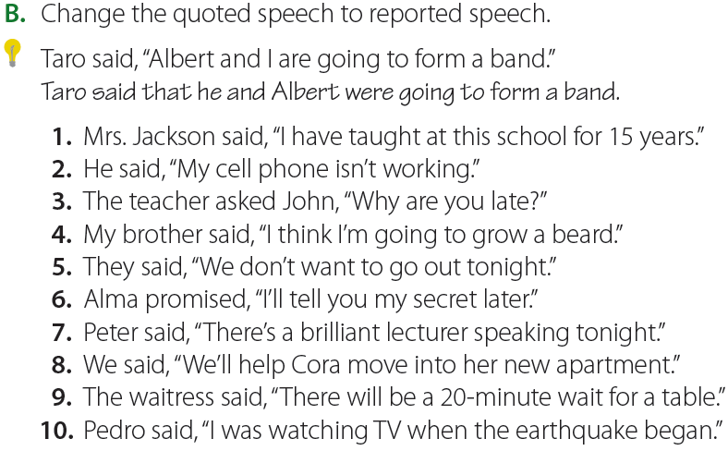
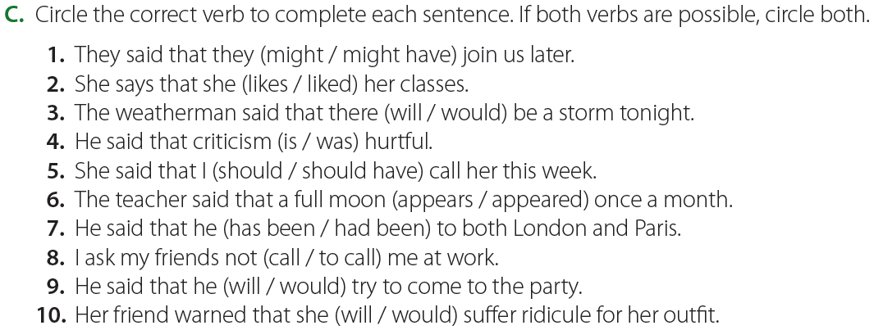
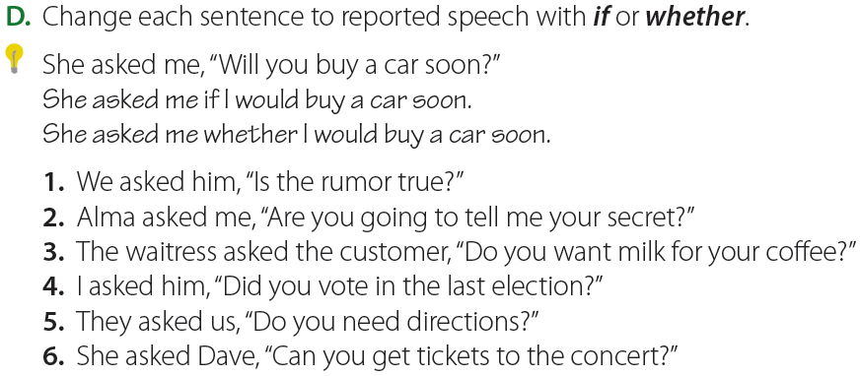

Grammatical Practice
Name ……………………………………………………………….…… Class …………. No. ……………
Unit 11 Express Yourself
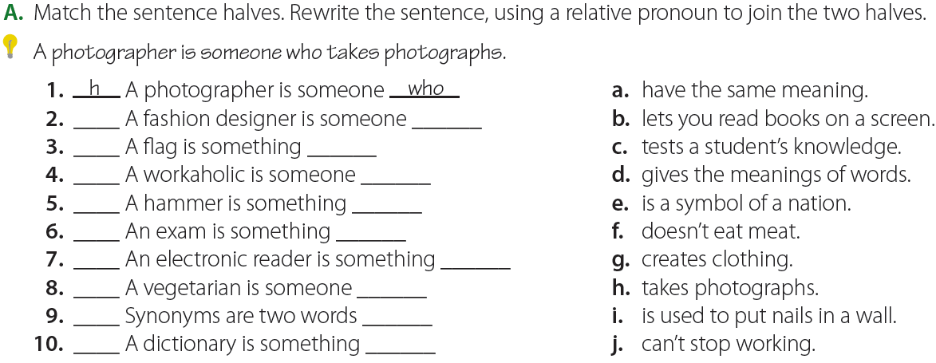
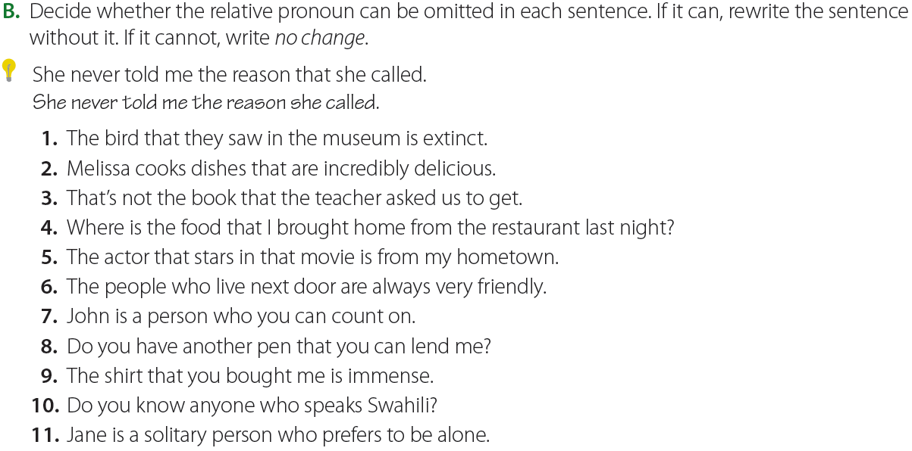
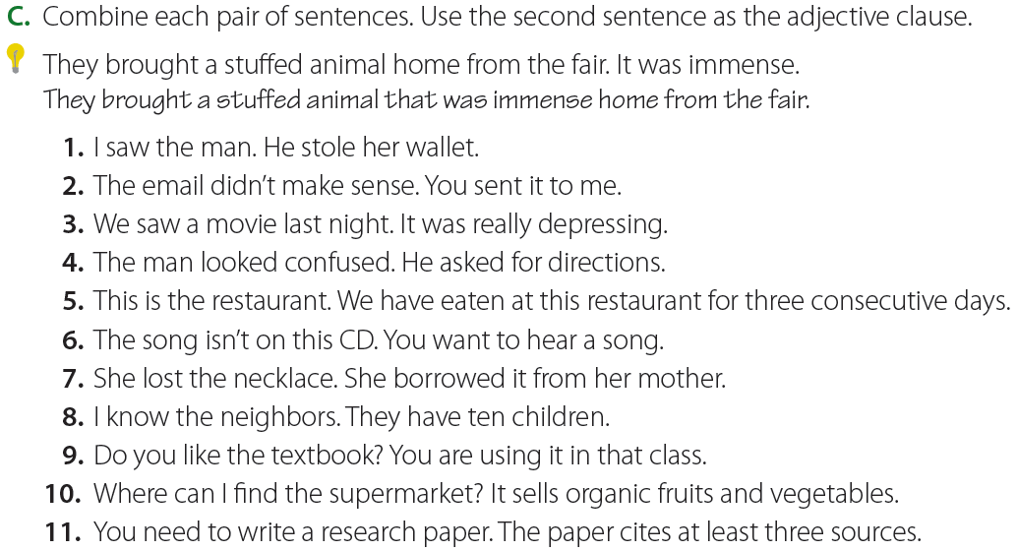
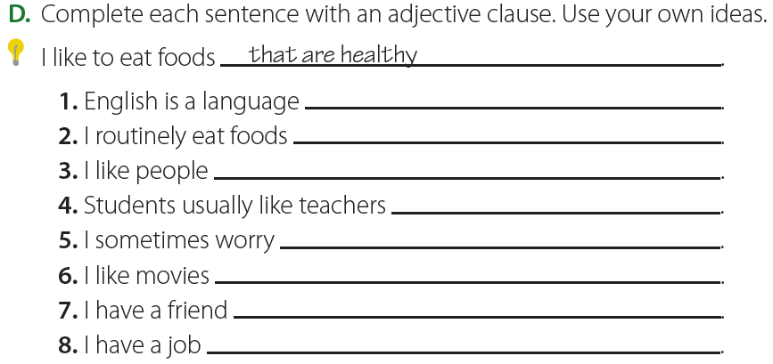
Grammatical Practice
Name ……………………………………………………………….…… Class …………. No. ……………
Unit 12 Lost and Found
