
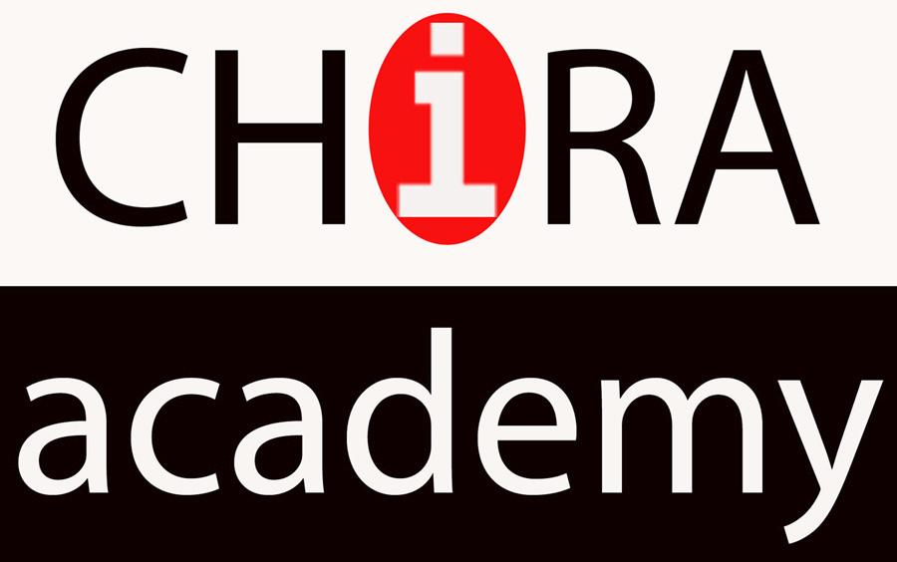

Application Form
Debsirin Knowledge Camp 2019

By Foundation for International Human Resource Development,

CHIRA academy and Debsirin Khonkaen School
.................................................................................................................................................................
Personal Information
ชื่อ นาย/นางสาว (ภาษาไทย)............................................................. นามสกุล.................................................................
First Name Mr. /Ms. (English) ................................................... Family Name.............................................................. Nickname................................ Age.............. Race………….. Nationality……………… Religion................................ Date of birth ......./............/............. Place of birth........................................ Shirt size ( S ) ( M ) ( L ) ( XL ) ………
School ...Debsirin...................................................................................................................... Level M. ........./..........
Program............................................. Reason for select this program...........................................................................
Address...........................................................................................................................................................................
City.....................................................................Post Code…………..…………Telephone……………………………….
Mobile Phone................................................... E-mail address .....................................................................................
Facebook…………………………………………………………….. Line ID ......................................................................
In Case of emergency please contact Name…………………………………………….… Relationship…………………
Address…………………………………………………………………………….. Telephone………………………..……….

Photo
1”
Grade Record
Grade Level | M.1 | M.2 | M.3 | M.4
GPA ( First Term )
GPA ( Second Term )

The subjects that you are interested in
1..............................................................................................................................
2..............................................................................................................................
3..............................................................................................................................
The expectations for further study
( ) Graduate Study
Faculty of................................................................................................................
Faculty of................................................................................................................
Faculty of................................................................................................................
( ) Other.....................................................................................................................................
( ) No education Because.........................................................................................................
Portfolio Activities ( In / External the school )
.........................................................................................................................................................................................
.................................................................................................................................................................................................................................................................................................................................................................................
Position of activist
1..........................................................................................................................................................
2..........................................................................................................................................................
Next
Are you interested in activities ?
1............................................................ because............................................................................................
2............................................................ because............................................................................................
Other Abilities............................................................................................................................................................
The favorite musical and favorite sport
1..............................................................................................................................
2..............................................................................................................................
Why are you interested in participating in this camp ?................................................................................
.........................................................................................................................................................................................
.........................................................................................................................................................................................
You think that the Debsirin Knowledge Camp is......................................................................
.........................................................................................................................................................................................
.........................................................................................................................................................................................
What are you expected for get from this camp ?...........................................................................................
.........................................................................................................................................................................................
.........................................................................................................................................................................................
**Remark You must have never been participated in the Debsirin knowledge camp

Signature..............................................................Camper
(............................................................)
.........../.............../.............

Recommendation by......................................................................Position.............................................................
.........................................................................................................................................................................................
.................................................................................................................................................................................................................................................................................................................................................................................

Signature..............................................................Teacher/Guardian
(............................................................)
.........../.............../.............
Staff use only
The decision of the committee’s first round ( 30-40 campers )
( ) Pass ………………………………………………………………………….
( ) No ………………………………………………………………………….
The decision of the committee’s last round (The camper)
( ) Pass ………………………………………………………………………….
( ) No ………………………………………………………………………….
Signature..............................................................Staff Coach
(............................................................)
.........../.............../.............

